N-200

3-jaw through-hole power chuck (adapter excluded)
- More large bore:
The largest bore in wedge type power operated chucks.
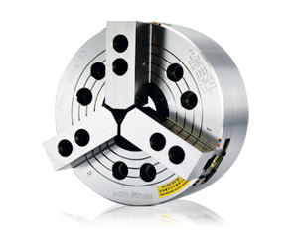
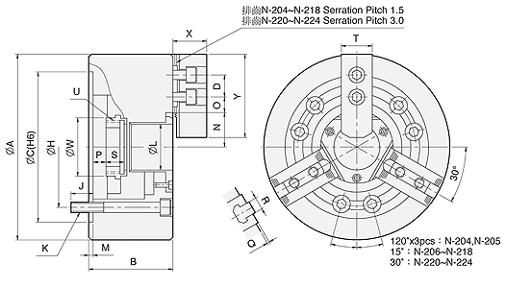
UNIT : mm
SPEC  Model | Through  -Hole  (mm) | Plunger  Stroke  (mm) | Jaw  stroke  (In Dia.)  (mm) | Max.  Pull  Force  (kgf) | Max.  Gripping  Force  (kgf) | Max.  Operating  Pressure  (kgf / cm²) | Max.  Speed  (r.p.m.) | Weight  (kg) | Moment  Of Inertia  I  (kg‧m² ) | Matching  Cylinder | Matching  Hard Jaw | Matching  Soft Jaw | Gripping  O.D. Range  (mm)
N-204 | Ø26 | 10 | 5.4 | 1428 | 2906 | 31.6 | 8000 | 4 | 0.007 | M0928 | HJ05 | HC04 | Ø4-Ø110
N-205 | Ø33 | 10 | 5.4 | 1784 | 3671 | 28.5 | 7000 | 7 | 0.018 | M1036 | HJ05 | HC05 | Ø6-Ø135
N-206 | Ø45 | 12 | 5.5 | 2243 | 5812 | 28.5 | 6000 | 13.5 | 0.057 | M1246 | HJ06 | HC06 | Ø15-Ø169
N-208 | Ø52 | 16 | 7.4 | 3558 | 9075 | 26.5 | 5000 | 23 | 0.17 | M1552 | HJ08 | HC08 | Ø20-Ø210
N-210 | Ø75 | 19 | 8.8 | 4385 | 11319 | 27.5 | 4200 | 35 | 0.315 | M1875 | HJ10 | HC10 | Ø25-Ø254
N-212 | Ø91 | 23 | 10.6 | 5812 | 14990 | 27.5 | 3300 | 56.5 | 0.737 | M2091 | HJ12 | HC12 | Ø30-Ø304
N-215 | Ø117.5 | 23 | 10.6 | 7240 | 18355 | 23.5 | 2500 | 111 | 2.27 | M2511 | HJ15 | HC15 | Ø50-Ø381
N-218 | Ø117.5 | 23 | 10.6 | 7240 | 18355 | 23.5 | 2000 | 131 | 3.55 | M2511 | HJ15 | HC15 | Ø50-Ø450
N-220 | Ø180 | 23 | 10.6 | 9177 | 23861 | 30.6 | 1800 | 190 | 6.5 | ML2816 | HJ24-1 | HC24-1 | Ø120-Ø510
N-224 | Ø205 | 26 | 12 | 9177 | 23861 | 26.5 | 1400 | 270 | 14.8 | ML3320 | HJ24-1 | HC-24-1 | Ø150-Ø610

DIM  Model | A | B | C  (H6) | D | H | J | K | L | M | N  max. | O  max. | O  min. | P  max. | P  min. | Q | R | S | T | U  max. | W | X | Y
N-204 | 110 | 59 | 85 | 14 | 70.6 | 16 | 3-M10x60 | 26 | 4 | 23.2 | 13.75 | 6.75 | 3.5 | -6.5 | 2 | 10 | 17.5 | 23 | M32x1.5 | 38 | 24 | 49.5
N-205 | 135 | 60 | 110 | 14 | 82.55 | 15 | 3-M10x60 | 33 | 4 | 26.5 | 19.75 | 7.75 | 1 | -9 | 2 | 10 | 20 | 25 | M40x1.5 | 45 | 31 | 54
N-206 | 169 | 81 | 140 | 20 | 104.78 | 16 | 6-M10x80 | 45 | 5 | 32 | 22.75 | 9.25 | 11 | -1 | 2 | 12 | 19 | 31 | M55x2 | 60 | 37 | 73
N-208 | 210 | 91 | 170 | 25 | 133.35 | 20 | 6-M12x90 | 52 | 5 | 38.7 | 29.75 | 11.75 | 14.5 | -1.5 | 2 | 14 | 20.5 | 35 | M60x2 | 66 | 38 | 95
N-210 | 254 | 100 | 220 | 30 | 171.45 | 22 | 6-M16x100 | 75 | 5 | 51 | 33.75 | 14.25 | 8.5 | -10.5 | 2 | 16 | 25 | 40 | M85x2 | 94 | 43 | 110
N-212 | 304 | 110 | 220 | 30 | 171.45 | 23 | 6-M16x110 | 91 | 6 | 61.3 | 45.75 | 15.75 | 8 | -15 | 2 | 21 | 28 | 50 | M100x2 | 108 | 51 | 130
N-215 | 381 | 133 | 300 | 43 | 235 | 35 | 6-M20x135 | 117.5 | 6 | 82 | 45.25 | 15.25 | 7 | -16 | 5 | 22 | 43 | 62 | M130x2 | 139 | 66 | 165
N-218 | 450 | 133 | 300 | 43 | 235 | 35 | 6-M20x135 | 117.5 | 6 | 82 | 79.75 | 15.25 | 7 | -16 | 5 | 22 | 43 | 62 | M130x2 | 139 | 66 | 165
N-220 | 510 | 134 | 380 | 60 | 330.2 | 35 | 6-M24x135 | 180 | 6 | 112.5 | 60.5 | 24.5 | 11 | -12 | 5 | 25 | 38 | 64 | M190x3 | 206 | 73 | 180
N-224 | 610 | 147 | 520 | 60 | 463.6 | 35 | 6-M24x150 | 205 | 6 | 139.9 | 87.5 | 24.5 | 16 | -10 | 5 | 25 | 38 | 64 | M215x3 | 230 | 73 | 180

