PB-ES(375)

Pneumatic power chuck
- Air chuck for external clamping with built-in pneumatic cylinder.
- Fast and clamping jaw stroke.
- Clamping pressure control.
- Clamping stroke control.
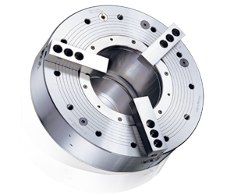
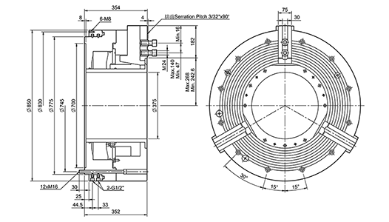
UNIT : mm
SPEC  Model | Through  -Hole  (mm) | Total  Stroke / Jaw  (mm) | Fast  Stroke / Jaw  (mm) | Clamping  Stroke / Jaw  (mm) | Piston  Area  (cm²) | Operating  Pressure  Min.-Max.(bar) | Gripping*  Force  (KN.) | Max.  Speed  (r.p.m.) | Weight  (kg) | Moment  Of Inertia  I  (kg‧m² ) | Air*  Consumption  (L)
850-375 | 375 | 25.4 | 13.4 | 125 | 1342 | 2-10 | 250 | 750 | 980 | 110 | 68
*When operating pressure at 6 bar.

