CRA

Collet chuck for short taper mount
- Collet chucks with bayonet catch are mainly used for chucking bar work on NC / CNC lathes.
- The bar can be fed in through the chuck.
- Profiles can also be chucked with the appropriate collets.
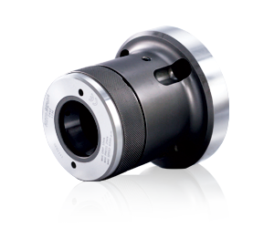
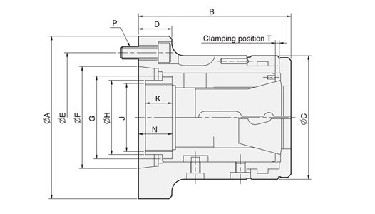
UNIT : mm
SPEC  Model | Matching  Spindle | Bar  Capacity  (mm) | Sleeve  Stroke  (mm) | Max.  Push  Force  KN(kgf) | Max.  Gripping  Force  KN(kgf) | Max.  Speed  (r.p.m.) | Weight  (kg)
CR26A4 | A2-4 | 26 | 5 | 20 (2039) | 44 (4486) | 7000 | 4.5
CR30A4 | A2-4 | 30 | 5 | 20 (2039) | 44 (4486) | 7000 | 4.1
CR42A5 | A2-5 | 42 | 7 | 25 (2549) | 55 (5608) | 6000 | 6.2
CR42A6 | A2-6 | 42 | 7 | 25 (2549) | 55 (5608) | 6000 | 8.2
CR60A6 | A2-6 | 60 | 7 | 30 (3059) | 65 (6628) | 5000 | 13
CR80A8 | A2-8 | 80 | 7 | 35 (3568) | 73 (7443) | 4000 | 21

DIM  Model | A | B | C | D | E | F | G | H | J  max. | K | N | P | T
CR26A4 | 112 | 103.5 | 85 | 30 | 82.55 | 63.513 | M50xP1.5 | 45 | M40xP1.5 | 15 | 21.7 | 3-M10 | 2.3
CR30A4 | 112 | 103.5 | 85 | 30 | 82.55 | 63.513 | M50xP1.5 | 45 | M40xP1.5 | 15 | 21.7 | 3-M10 | 2.3
CR42A5 | 135 | 124 | 100 | 27 | 104.78 | 82.563 | M66xP1.5 | 60 | M55xP2.0 | 25 | 27.4 | 4-M10 | 3.1
CR42A6 | 170 | 124 | 100 | 32 | 133.35 | 106.375 | M66xP1.5 | 66 | M60xP2.0 | 22 | 27.4 | 4-M12 | 3.1
CR60A6 | 170 | 145 | 130 | 27 | 133.35 | 106.375 | M90xP1.5 | 80 | M74xP2.0 | 30 | 29.9 | 4-M12 | 3.1
CR80A8 | 220 | 170 | 156 | 35 | 171.45 | 139.719 | M114xP2.0 | 99 | M90xP2.0 | 27.5 | 32.4 | 6-M16 | 6.1

Capacities  Chuck | MULTIBORE | SPRING COLLET
NO. | Cat.No. / ○ / / □ | Cat.No. / ○ / / □
CR26 | M-667 / 26 / 22 / 18 | 161E / 8744 / 30 / 26 / 18
CR30 | M-669 / 30 / 26 / 21 | 163E / 4249 / 30 / 26 / 21
CR42 | M-673 / 42 / 36 / 30 | 173E / 4728 / 42 / 36 / 30
CR60 | M-677 / 60 / 52 / 42 | 185E / 4291 / 60 / 52 / 42
CR80 | J-660 / 80 / 69 / 56 | 193E / H-47 / 80 / 69 / 56
*Uses the collet to DIN6343 specification.
