MS250C/MS300C

Non through-hole rotary hydraulic cylinder (valve and switch brackets included)
- Through-hole for coolant, oil or air with thread for rotary unit.
- Mounting from the rear or front side.
- Built-in safety check valves and bracket for proximity switch. (The proximity switches are extra option.)
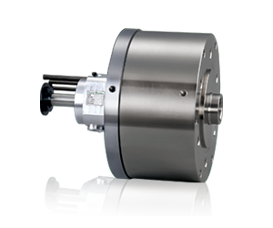
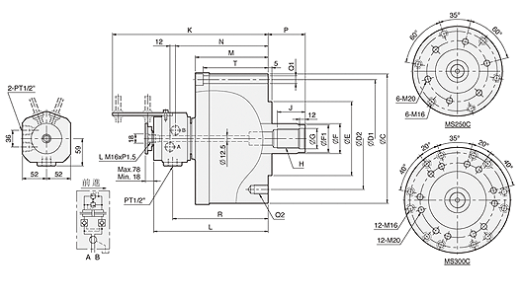
UNIT : mm
SPEC  Model | Piston  Dia.  (mm) | Piston Area  (cm²)  Push Side / Pull Side | Max. Draw Bar Force  KN(kgf)  Push Side / Pull Side | Piston  Stroke  (mm) | Max.  Operating  Pressure  MPa  (kgf / cm²) | Max.  Speed  (r.p.m.) | Moment  Of Inertia  I  (kg‧m² ) | Weight  (kg) | Total  Leakage  L/min
MS250C | 250 | 481.5 / 453.6 | 227(23147) / 214(21822) | 60 | 4.9(50) | 2000 | 0.87 | 78 | 2
MS300C | 300 | 697.5 / 658.6 | 262(26716) / 247(25186) | 60 | 4.0(40.8) | 1500 | 1.6 | 106 | 3

DIM  Model | C | D1 | D2 | E  (h7) | F | F1 | G | H | J | K | L | M | N | P  max. | P  min. | Q1 | Q2 | R | T
MS250C | 300 | 275 | 220 | 160 | 65 | 62 | 44 | M42x3.0 | 60 | 356 | 177 | 177 | 220 | 85 | 25 | 6-Ø17 | 6-M20x30 | 226 | 160
MS300C | 355 | 330 | 270 | 210 | 75 | 70 | 50 | M48X3.0 | 70 | 359 | 182 | 182 | 223 | 85 | 25 | 12-Ø17 | 12-M20x30 | 229 | 165

