T-NUTS

T-NUTS
- Suitable for power chuck
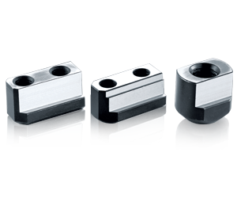
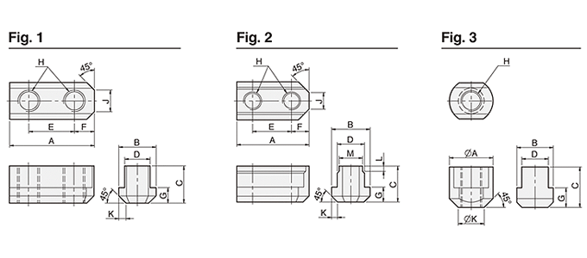
UNIT : mm
DIM  Model | A | B | C | D | E | F | G | H | J | K | L | M | Fig | Matching  Chuck
N-205 | 26 | 14.5 | 15 | 10 | 14 | 6 | 5.5 | M8 | 5 | 2 | – | – | 1 | N-204, N-205
N-206 | 36 | 17.5 | 18.5 | 12 | 20 | 8.2 | 7.5 | M10 | 8 | 2.5 | – | – | 1 | N-206, NB-306
N-208 | 46.5 | 20.5 | 20.5 | 14 | 25 | 10.5 | 8.5 | M12 | 12 | 4 | – | – | 1 | N-208, NB-208
N-210 | 51 | 20.5 | 21.5 | 16 | 30 | 11 | 8.5 | M12 | 11 | 3 | – | – | 1 | N-210, NB-210
N-212 | 55.5 | 29.5 | 27.8 | 21 | 30 | 12 | 11.5 | M16 | 13 | 4.5 | – | – | 1 | N-212, NB212
N-215 | 80 | 33.5 | 45.5 | 24 | 43 | 17 | 16.5 | M20 | 11 | 5 | 8 | 22 | 2 | N-215, N-218
V-206 | 36.5 | 17.5 | 22.5 | 12 | 20 | 7.5 | 7.5 | M10 | 6 | 3 | – | – | 1 | V-206, NHT-208
V-208 | 48 | 20.5 | 25.5 | 14 | 25 | 11 | 9.5 | M12 | 8 | 4 | – | – | 1 | V-208
V-210 | 55 | 22.5 | 25.5 | 16 | 30 | 11 | 9.5 | M12 | 8 | 4 | – | – | 1 | V-210
V-212 | 55.5 | 26.5 | 33.5 | 18 | 30 | 11.5 | 13.5 | M14 | 12 | 5 | – | – | 1 | V-212
V-215 | 42 | 35 | 29.2 | 25.5 | – | – | 19 | M20 | – | 25 | – | – | 3 | V-215, V-218
V-215 26 M20 | 42 | 35 | 41.2 | 26 | – | – | 19 | M20 | – | 25 | – | – | 3 | V-215P3.0
V-224 | 46 | 37.5 | 45 | 25 | – | – | 19 | M20 | – | 26.5 | – | – | 3 | N-220, N-224, V-221, V-224, V-232

