MS-C

Non through-hole rotary hydraulic cylinder (valve and switch brackets included)
- Built-in safty check valves and detective plate.
- The proximity switches are extra option.
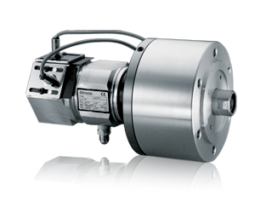
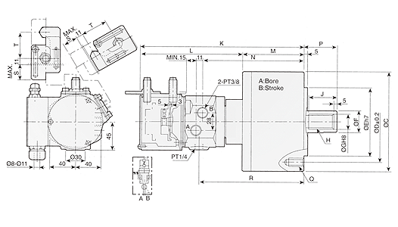
UNIT : mm
SPEC  Model | Piston Area  (cm²)  Push Side / Pull Side | Max. Draw Bar Force  KN(kgf)  Pull Side | Piston  Stroke  (mm) | Max.  Operating  Pressure  MPa  (kgf / cm²) | Max.  Speed  (r.p.m.) | Moment  Of Inertia  I  (kg‧m² ) | Weight  (kg) | Total  Leakage  L/min
MS105C | 84 / 79 | 29 (2957) | 20 | 4.0(40.8) | 6000 | 0.0125 | 7.6 | 0.8
MS125C | 120 / 113 | 42 (4283) | 25 | 4.0(40.8) | 6000 | 0.022 | 10.5 | 0.8
MS125C35 | 120 / 113 | 42 (4283) | 35 | 4.0(40.8) | 6000 | 0.022 | 10.5 | 0.8
MS150C | 174 / 160 | 60 (6118) | 30 | 4.0(40.8) | 5500 | 0.047 | 14 | 0.8
MS200C | 312 / 290 | 108 (11013) | 35 | 4.0(40.8) | 5500 | 0.097 | 22.5 | 0.8

DIM  Model | A | B | C | D | E | F | G | H | j | K | L | M | N | P  max. | P  min. | Q | R | S | T
MS105C | 105 | 20 | 135 | 100 | 80 | 30 | 21 | M20xP2.5 | 35 | 257 | 168 | 89 | 152 | 45 | 25 | 6-M10x20 | 158 | 23 | 46
MS125C | 125 | 25 | 160 | 130 | 110 | 35 | 25 | M24xP3.0 | 44 | 265 | 168 | 97 | 160 | 51 | 26 | 6-M12x24 | 166 | 23 | 46
MS125C35 | 125 | 30 | 160 | 130 | 110 | 35 | 25 | M24xP3.0 | 44 | 269 | 168 | 101 | 164 | 57 | 22 | 6-M12x24 | 170 | 23 | 46
MS150C | 150 | 30 | 190 | 130 | 110 | 45 | 31 | M30xP3.5 | 45 | 274 | 168 | 106 | 169 | 56 | 26 | 12-M12x24 | 175 | 23 | 46
MS200C | 200 | 35 | 245 | 145 | 120 | 55 | 37 | M36xP4.0 | 60 | 288 | 168 | 122 | 183 | 69 | 34 | 12-M16x30 | 189 | 28 | 46
- Draw bar pull force : Pressure 4.0 MPa(40.8kgf / cm²)
- Total leakage : Pressure 3.0 MPa(30.6kgf / cm²) and oil temperature 50°C
- Proximity switch : Model BESS 16-329-E4-Y (BALLUFF) DC 12 / 24V 200mA NPN

