SE

6-jaw scroll chuck plain back
- SE types are specially meet for drilling*endmilling*tapping or grinding in tool grinders.
- Huge bore diameter design for wider application of bar workpieces.
- SE type feature gripping for thin tube and high roundness accuracy.
- The body is made of MEEHANITE. It is suitably used for high speed revolution and 3 times more durable than regular material.
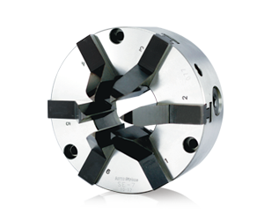
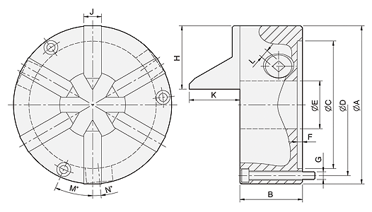
UNIT : mm
SPEC  Model | A | B | C | D | E | F | G | H | J | K | L | M | N | Allowable  Handle  Torque  (kgf‧m) | Gripping  Force  (kgf) | Max.  Speed  (r.p.m.) | Weight  (kg) | Moment  Of Inertia  I  (kg‧m² ) | Gripping Range
 |  |  |  |  |  |  |  |  |  |  |  |  |  |  |  |  |  |  | O.D. Range / I.D. Range
SE-4 | 112 | 66 | 80 | 95 | 32 | 4.8 | 3-M8x65 | 45 | 14 | 39.7 | 8 | 30 | 6.5 | 1.6 | 440 | 1200 | 4 | - | Ø2-Ø32
SE-6 | 165 | 67 | 130 | 147 | 51 | 5.5 | 3-M8x70 | 66.5 | 19 | 40.7 | 10 | 23.3 | 6.2 | 2.8 | 660 | 1200 | 9 | 0.03 | Ø3-Ø51
SE-7 | 192 | 76.5 | 155 | 172 | 80 | 5.5 | 3-M10x75 | 77 | 21.5 | 61.5 | 11 | 24 | 5.3 | 3.6 | 850 | 1000 | 14 | 0.06 | Ø3-Ø81

