V

3-jaw wedge type non through-hole power chuck (adapter excluded)
- High performance :
Similar high performance with N series.
- Chuck mounting screws :
Metric or UNC socket head cap screws are supplied for installing the chuck to the spindle.
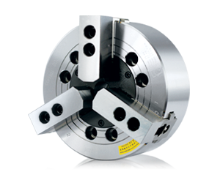
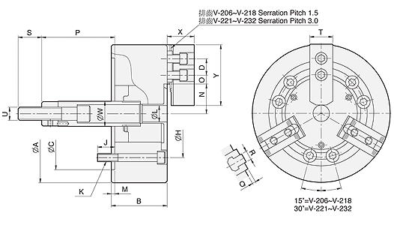
UNIT : mm
SPEC  Model | Jaw | Plunger  Stroke  (mm) | RadialJaw.  Stroke  +(Manual setting  (mm) | Max.  Pull  Force  (kN) | Max.  Gripping  Force  (kN) | Max.  Operating  (r.p.m.) | Max.  Speed  (r.p.m.) | Weight  (kg) | Moment  Of Inertia  I  (kg‧m² ) | Matching  Cylinder | Matching  Hard Jaw | Matching  Soft Jaw | Gripping  O.D. Range  (mm)
40" V-240VIT-240 | 3 | 57 | 23 + (30) | 180 | 320 | 42.8 | 630 | 645 | 82 | MS250C | HJ40-1 | HC40-1 | Ø285-Ø1005
 | 4 |  |  |  |  |  | 550 | 700 | 89
50" V-250VIT-250VE-250 | 3 | 57 | 23 + (30) | 180 | 320 | 42.8 | 500 | 890 | 168 | MS250C | HJ40-1 | HC40-1 | Ø270-Ø1250
 | 4 |  |  |  |  |  | 400 | 940 | 177
 | 6 |  |  |  |  |  | 360 | 971 | 183
63" V-263VIT-263VE-263 | 3 | 60 | 24 + (40) | 200 | 360 | 46.9 | 400 | 1800 | 548 | MS250C | HJ40-1 | HC40-1 | Ø390-Ø1600
 | 4 |  |  |  |  |  | 300 | 1700 | 518
 | 6 |  |  |  |  |  | 280 | 1800 | 548
79" VE-279 | 6 | 60 | 24 + (40) | 200 | 360 | 46.9 | 230 | 2850 | 1350 | MS250C HJ40-1 | HJ40-1 | HC40-1 | Ø440-Ø2000

DIM  Model | A | B | C | D  max | H | J | K | L | M | N  max. | O. | P  max. | P  min. | Q | R | S | T | U
40" V-240  VIT-240 | 1005 | 180 | 520 | 502 | 463.6 | 108 | M24 | M52x1.5 | 8 | 457 | 30 | 59 | 2 | 4 | 7-M24 | 19 | 85 | 72
50" V-250  VIT-250  VE-250 | 1250 | 180 | 520 | 623 | 463.6 | 108 | M24 | M52x1.5 | 8 | 563 | 30 | 59 | 2 | 4 | 10-M24 | 19 | 85 | 72
63" V-263  VIT-263  VE-263 | 1600 | 220 | 720 | 796 | 647.6 | 144 | M30 | M52x1.5 | 8 | 738 | 40 | 82 | 22 | 6 | 13-M24 | 22 | 110 | 72
79" | 2000 | 238 | 720 | 996 | 647.6 | 159 | M30 | M52x1.5 | 8 | 914 | 40 | 100 | 40 | 6 | 17-M24 | 22 | 110 | 72

