MM

Super high speed through-hole compact rotary hydraulic cylinder
- Compact hydraulic cylinder design with light weight can reduce the spindle loading while running in high speed.
- Built-in check valve in safety auto lock and pressure relief valve in case of power failure occur.
- New model developed for rear installation.
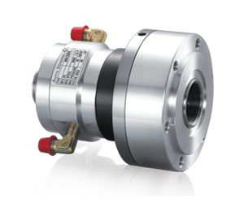
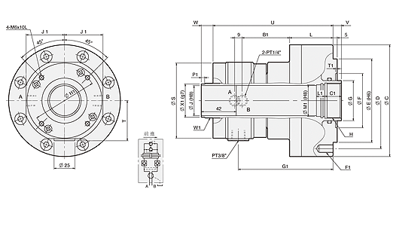
UNIT : mm
SPEC  Model | Piston  Dia.  (mm) | Piston Area  (cm²)  Push Side / Pull Side | Max. Draw Bar Force  KN(kgf)  Push Side / Pull Side | Piston  Stroke  (mm) | Max.  Operating  Pressure  MPa  (kgf / cm²) | Max.  Speed  (r.p.m.) | Moment  Of Inertia  I  (kg‧m² ) | Weight  (kg) | Total  Leakage  L/min
MM1036A | 36 | 64 / 60 | 23.8(2427) / 22.3(2274) | 5 | 4.0(40.8) | 8000 | 0.013 | 7 | 0.8
MM1246A | 46 | 100 / 89 | 38(3875) / 33(3365) | 15 | 4.0(40.8) | 7000 | 0.026 | 9.8 | 3.0

DIM  Model | C | D | E | F | G | H | J | L | T | U | V  max. | V  min. | W  max. | W  min. | B1 | C1 | F1 | G1 | H1 | J1 | L1 | M1 | Q1 | T1 | W1 | P1 | X1
MM1036A | 134 | 115 | 100 | 65 | 48 | M42xP1.5 | 36 | 52 | 48 | 144 | 10 | 5 | 17 | 12 | 57 | 20 | 6-M10x15 | 113.5 | 76 | 46 | 10 | 38 | M4x9L | 2 | M42xP1.5 | 2 | 40
MM1246A | 155 | 130 | 100 | 80 | 65 | M55xP2.0 | 46 | 76 | 61 | 179 | 15 | 0 | 40 | 25 | 59.5 | 30 | 12-M10x20 | 140 | 98 | 59 | 15 | 50 | M6x10L | 6 | M52xP1.5 | 9 | 50

