DR

3-jaw draw down power chuck
Draw down power chuck feature of radial clamping will lead to almost no work piece uplifting displacement; for machining casting and forging part:
- For the clamped work-piece is appressed to the surface, chucks are suitable for heavy machining.
- Chuck Actutors with cylindrical structure are durable and ensures high clamping repeatability.
- Accurate self-centering and pull back features are adequate or precise length control machining requirements.
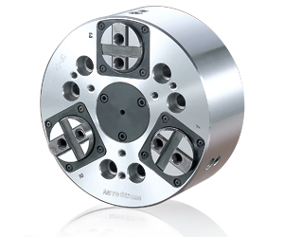
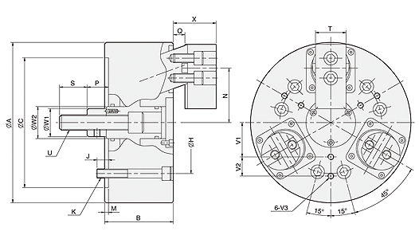
UNIT : mm
SPEC  Model | Plunger  Stroke  (mm) | Jaw  Stroke  (In Dia.)  (mm) | Max.  Pull  Force  kN(kgf) | Max.  Gripping  Force  kN(kgf) | Max.  Operating  Pressure  MPa(kgf/cm²) | Max.  Speed  (r.p.m.) | Weight  (kg) | Moment  Of Inertia  I  (kg‧m² ) | Matching  Cylinder | Matching  Soft Jaw | Gripping  O.D. Range  (mm)
DR-06 | 10 | 7.2 | 15(1530) | 25(2549) | 2.1(21.4) | 3500 | 15 | 0.05 | MS105C | DR06-HC | Ø35-Ø165
DR-08 | 10 | 7.2 | 25(2590) | 45(4589) | 2.5(25.5) | 3000 | 25 | 0.14 | MS125C | DR08-HC | Ø40-Ø210

DIM  Model | A | B | C | H | J | K | M | N  max. | N  min. | P  max. | P  min. | Q  max. | Q  min. | S | T | U | W1 | W2 | X  max. | X  min. | V1 | V2 | V3
DR-06 | 165 | 85 | 140 | 104.78 | 16 | 6xM10 | 5 | 58 | 54.4 | 33 | 23 | 14 | 4 | 36 | 35 | M16x2.0 | 32 | 33.5 | 45 | 35 | 35 | 20 | M6x12
DR-08 | 210 | 90 | 170 | 133.35 | 15 | 6xM12 | 5 | 71.3 | 67.7 | 38 | 28 | 15 | 5 | 36 | 40 | M20x2.5 | 37 | 42 | 56 | 46 | 45 | 25 | M8x16

