BL

3-jaw ball swing lock chuck
- The chuck can attract the workpiece and hold it on.
The jaw operates in two stages :
Clamping pull back, so it can hold the workpiece exactly on the position in front of the chuck, and make it under the stabile situation.
- The chuck can grasp the workpiece on both O.D. and I.D. clamping.
The chuck can switch between O.D. and I.D. clamping mode by a simple operation.
- The chuck can grasp the part of the taper. The chcuk can exactly grasp the black surface of the cast irons, which has draft.
So the discard process can be ignored on the chucking part of the workpiece.(It can grasp up to a 20 degree taper when using a clipper.)
- The jaw can equalize on the O.D. clamping, so it can grasp the workpiece steady. (Jaw self-equalizing to max 5°)
- Dustproof performance is excellent. It is differ from regular general purpose chuck. It is structurally dustproof. Especially there is a dustproof seal in the part of lock arm to prevent the dust.
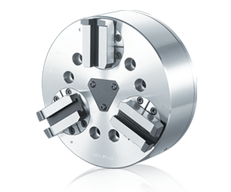
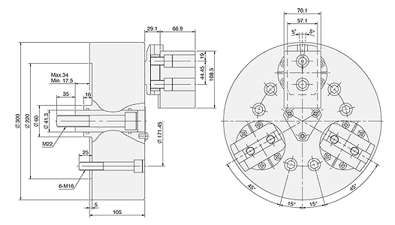
單位 : mm
SPEC  Model | Plunger  Stroke  (mm) | Jaw  Stroke  (In Dia.)  (mm) | Max.  Pull  Force  kN(kgf) | Max.  Gripping  Force  kN(kgf) | Max.  Operating  Pressure  MPa(kgf/cm²) | Max.  Speed  (r.p.m.) | Weight  (kg) | Moment  Of Inertia  I  (kg‧m² ) | Matching  Cylinder | Matching  Soft Jaw | Gripping Range  O.D. Range / I.D. Range
BL-12 | 17.5 | 12.4 | 40.7(4152) | 122(12440) | 2.8(28.5) | 2800 | 65 | 0.18 | MS150C | BL12 | Ø63-Ø240 / Ø127-Ø305

