F52

High speed and light weight type strong finger chuck for aluminum wheel
- All sliding surfaces are hardened and ground for accurate actual running and long service repeatability.
- Mounting : Adaptor mounting to fit with DIN, ISO, BS, ASA, B5-9 type A spindles.
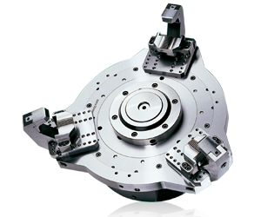
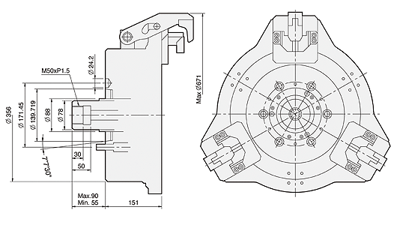
UNIT : mm
SPEC  Model | Applicable  Wheel Size | Out Dai.  Of Chuck  (mm) | Available  Spindle Nose | Max.  Pull  Force  (kgf) | Max.  Gripping  Force  (kN) | Max.  Operating  Pressure  MPa(kgf/cm²) | Max.  Speed  (r.p.m.) | Weight  (Without Jigs)  (kg) | Matching  Cylinder
F52A8 | 12"-18" | 521 | A2-8 | 3000 | 3300 | 2.9(29.5) | 2800(18"2200) | 98 | MS125C35

