ADAPTER

Mounting adapter
- Mounting adapter on short taper spindle noses DIN55026
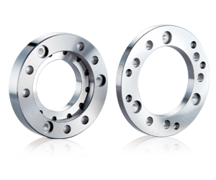
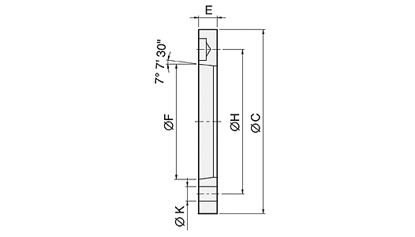
TYPE1 UNIT : mm
DIM  Model | Spindle  Nose | C | F | H | K | E | Matching  Chuck
N0205-0J4 | A4 | 110 | 63.513 | 82.55 | 3-11 | 15 | N-205
N0205-0J42 | A4 | 110 | 63.513 | 82.55 | 4-11 | 15 | NT-205
N0206-0J5 | A5 | 140 | 82.563 | 104.78 | 6-11 | 15 | N-206, NB-306, V-206
N0206-0J52 | A5 | 140 | 82.563 | 104.78 | 6-11 | 15 | NT-206, VT-206
N0206-0J54 | A5 | 140 | 82.563 | 104.78 | 4-11 | 15 | NIT-206
N0208-0J6 | A6 | 170 | 106.375 | 133.35 | 6-13 | 17 | N-208, NB-208, V-208
N0208-0J62 | A6 | 170 | 106.375 | 133.35 | 6-13 | 17 | NT-208, VT-208
N0208-0J64 | A6 | 170 | 106.375 | 133.35 | 4-13 | 17 | NIT-208
NHT0208-0J6 | A6 | 170 | 106.375 | 133.35 | 6-13 | 17 | NHT-208
N0210-0J8 | A8 | 220 | 139.719 | 171.45 | 6-17 | 18 | N-210, N-212, NB-210, V-210, V-212
N0210-0J82 | A8 | 220 | 139.719 | 171.45 | 6-17 | 18 | NT-210, NT-212, VT-210, VT-212
N0210-0J84 | A8 | 220 | 139.719 | 171.45 | 4-17 | 18 | NIT-210, NIT-212, VIT-212
N0215-0J11 | A11 | 300 | 196.869 | 235 | 6-21 | 22 | N-215, N-218, NB-212, V-215, V-218
N0215-0J112 | A11 | 300 | 196.869 | 235 | 6-21 | 22 | NT-215, VT-215
N0215-0J114 | A11 | 300 | 196.869 | 235 | 4-21 | 22 | NIT-215, VIT-218
V0224-0J15 | A15 | 380 | 285.775 | 330.2 | 6-25 | 27 | N-220, V-221, V-224, V-232, NB-215, NB-218
V0224-0J154 | A15 | 380 | 285.775 | 330.2 | 8-25 | 27 | VIT-224, VIT-232
N0224-0J20 | A20 | 520 | 412.775 | 463.6 | 6-25 | 25 | N-224, N-232, V-240, V-250
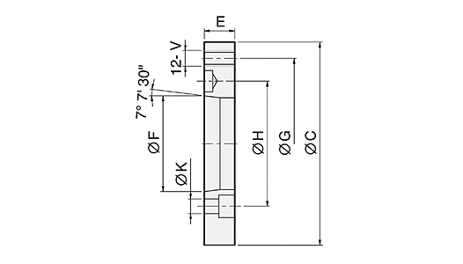
TYPE2 UNIT : mm
DIM  Model | Spindle  Nose | C | F | H | K | G | V | E | Matching  Chuck
N0206-0J4 | A4 | 140 | 63.513 | 82.55 | 11 | 104.78 | M10 | 20 | N-206, NT-206, NIT-206,  NB-306, V-206, VT-206
N0208-0J5 | A5 | 170 | 82.563 | 104.78 | 11 | 133.35 | M12 | 23 | N-208, NT-208, NIT-208,  NHT-208 ,NB-208, V-208,  VY-208
N0210-0J6 | A6 | 220 | 106.375 | 133.35 | 13 | 171.45 | M16 | 25 | N-210, NT-210, NIT-210,  N-212, NT-212, NIT-212,  V-210, VT-210, V-212,  VT-212, VIT-212
N0215-0J8 | A8 | 300 | 139.719 | 171.45 | 17 | 235 | M20 | 33 | N-215, NT-215, NIT-215,  N-218, NB-212, V-215,  VT-215, V-218, VIT-218
N0220-0J11 | A11 | 380 | 196.869 | 235 | 21 | 330.2 | M24 | 41 | N-220, VIT-232, NB-215,  NB-218
N0224-0J11 | A11 | 520 | 196.869 | 235 | 21 | 463.6 | M24 | 45 | N-224, N-232, V-240, V-250
N0224-0J15 | A15 | 520 | 285.775 | 330.2 | 25 | 463.6 | M24 | 42 | N-224, N-232, V-240, V-250
V0224-0J8 | A8 | 380 | 139.719 | 171.45 | 17 | 330.2 | M24 | 33 | V-221, V-224, V-232
V0224-0J11 | A11 | 380 | 196.869 | 235 | 21 | 330.2 | M24 | 27 | V-221, V-224, V-232
V0263-0J20 | A20 | 720 | 412.775 | 463.6 | 27 | 647.6 | M30 | 50 | VIT-263, VE-263, VE-279
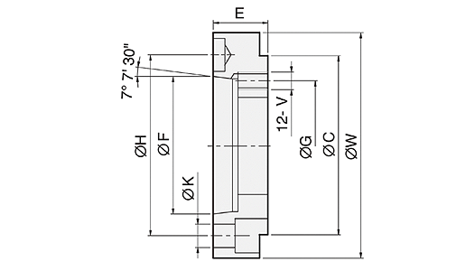
TYPE3 UNIT : mm
DIM  Model | Spindle  Nose | C | F | H | K | G | V | W | E | Matching  Chuck
N0205-0J5 | A5 | 110 | 82.563 | 104.78 | 11 | 82.55 | M10 | 128 | 32 | N-205, NT-205
N0206-0J6 | A6 | 140 | 106.375 | 133.35 | 13 | 104.78 | M10 | 168 | 35 | N-206, NT-206, NB-306,  V-206, VT-206
N0208-0J8 | A8 | 170 | 139.719 | 171.45 | 17 | 133.35 | M12 | 208 | 40 | N-208, NT-208, NIT-208,  NB-208, V-208, VT-208
N0212-0J11 | A11 | 220 | 196.869 | 235 | 21 | 171.45 | M16 | 278 | 50 | N-210, NT-210, NIT-210,  N-212, NT-212, NIT-212,  NB-210, V-210, VT-210,  V-212, VT-212, VIT-212
N0215-0J15 | A15 | 300 | 285.775 | 330.2 | 25 | 235 | M20 | 378 | 57 | N-215, NT-215, NIT-215,  N-218, NB-212, V-215,  VT-215, V-218, VIT-218
V0224-0J20 | A20 | 380 | 412.775 | 463.6 | 26 | 330.2 | M24 | 520 | 58 | N-220, V-221, V-224,  V-232

