HC

Soft jaw for hydraulic power chuck
- Soft jaws for hydraulic power chucks.
- CSoft jaw for CNC lathe.
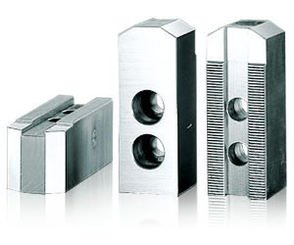
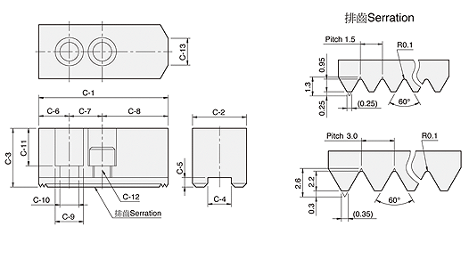
UNIT : mm
DIM  Model | C-1 | C-2 | C-3 | C-4 | C-5 | C-6 | C-7 | C-8 | C-9 | C-10 | C-11 | C-12 | C-13 | Serration  Pitch | Matching  Chuck | 3 Jaw  Weight  (kg)
HC04 | 53 | 23 | 23 | 10 | 5 | 9 | 14 | 30 | 14 | 9 | 14 | M8 | 30 | 1.5x60° | N-204 | 0.45
HC05 | 62 | 25 | 30 | 10 | 5 | 9 | 14 | 39 | 14 | 9 | 21 | M8 | 5 | 1.5x60° | N-205 | 0.7
HC06 | 73 | 31 | 36 | 12 | 5 | 15 | 20 | 38 | 17 | 11 | 21 | M10 | 14 | 1.5x60° | N-206, NB-306, V-206 | 1.5
HC08 | 95 | 35 | 37 | 14 | 5 | 24 | 25 | 46 | 19 | 13 | 22 | M12 | 16 | 1.5x60° | N-208, NB-208, V-208 | 2.4
HC10 | 110 | 40 | 42 | 16 | 5 | 30 | 30 | 50 | 19 | 13 | 27 | M12 | 18 | 1.5x60° | N-210, NB-210, V-210 | 3.7
HC12 | 130 | 50 | 50 | 21 | 5 | 39 | 30 | 61 | 25 | 17 | 33 | M16 | 23 | 1.5x60° | N-212, NB-212 | 6.5
HC15 | 165 | 62 | 62 | 22 | 8 | 37 | 43 | 85 | 32 | 21 | 38 | M20 | – | 1.5x60° | N-215, N-218, NB-215, NB-218 | 12.5
HC08-1 | 95 | 35 | 37 | 12 | 5 | 24 | 20 | 51 | 17 | 11 | 21 | M10 | 14 | 1.5x60° | NHT-208 | 2.4
HC12-1 | 130 | 50 | 50 | 18 | 5 | 39 | 30 | 61 | 23 | 15 | 30 | M14 | 23 | 1.5x60° | V-212, V-212R | 6.6
HC15-1 | 165 | 62 | 62 | 25.5 | 5 | 37 | 43 | 85 | 32 | 21 | 38 | M20 | – | 1.5x60° | V-215, V-218, V-215R, V-218R | 12.5
HC24-1 | 180 | 64 | 70 | 25 | 9 | 40 | 60 | 80 | 32 | 21 | 45 | M20 | – | 3.0x60° | N-220, N-224, V-221, V-224,V-221R,V-224R | 15.8
HC32-1 | 210 | 74 | 90 | 25 | 9 | 40 | 80 | 90 | 32 | 21 | 65 | M20 | – | 3.0x60° | V-232 | 29.2
HC15-2 | 156 | 64 | 70 | 26 | 9 | 34 | 50 | 72 | 32 | 21 | 45 | M20 | – | 3.0x60° | V-215(P3.0).V-218(P3.0). | 13.4

Soft jaw for draw down power chuck
UNIT : mm
DIM  Model | C-1 | C-2 | C-3 | C-4 | C-5 | C-6 | C-7 | C-8 | C-9 | C-10 | C-11 | C-12 | C-13 | Matching  Chuck | 3 Jaw  Weight  (kg) | Reference
DR-06 | 70 | 35 | 34 | 10 | 6 | 43 | – | 10 | 23 | 15.5 | 21 | M14 | 2.5 | DR-6 | 1.5 | Fig-1
DR-08 | 84 | 40 | 44.5 | 16 | 7 | 53 | 26 | 12 | 20 | 13.5 | 29 | M12 | 3.5 | DR-8 | 2.7 | Fig-2
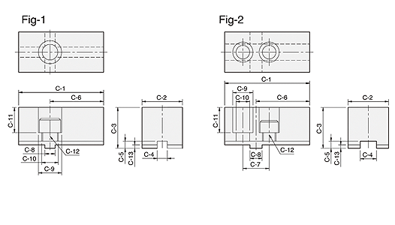

Soft jaw for ball swing lock chuck
UNIT : mm
DIM  Model | C-1 | C-2 | C-3 | C-4 | C-5 | C-6 | C-7 | C-9 | C-10 | C-11 | C-12 | Matching  Chuck | 3 Jaw  Weight  (kg)
BL-12 | 108 | 70 | 70 | 57.1 | 3.3 | 19 | 44.45 | 25 | 17 | 59 | M16 | BL-12 | 10.6
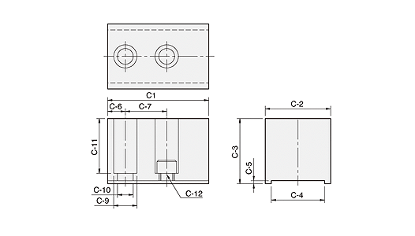

Soft jaw for pneumatic power chuck
UNIT : mm
DIM  Model | C-1 | C-2 | C-3 | C-4 | C-5 | C-6 | C-7 | C-8 | C-9 | C-10 | C-11 | C-12 | C-13 | Matching Chuck | 3 Jaw Weight (kg)
PB600 | 205 | 60 | 60 | 25.5 | 6 | 25 | 38 | 104 | 32 | 21 | 44 | M20 | 55 | PB-ES600 | 13.5
PB850 | 320 | 80 | 80 | 30 | 7 | 35 | 60 | 165 | 38 | 26 | 53 | M24 | 110.5 | PB-ES850 | 40.2
