MH

Non through-hole rotary hydraulic cylinder
- Compact, low inertla, light weight cylinder :
Manufuctured by aluminium alloy, this cylinder is light weight design to reduce the loading of spindle.
- High speed :
This balanced design cylinder is light weight, compact and maintains outstanding stability during high speed operation.
- Long life :
High quality cylinder seals and high accuracy surface finish on components to ensure the long life of these cylinders.
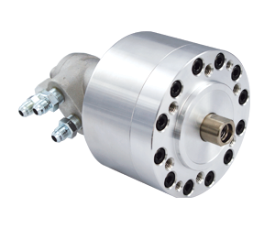
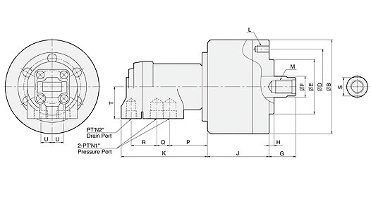
UNIT : mm
SPEC  Model | Piston  Dia.  (mm) | Piston Area  (cm²)  Push Side / Pull Side | Max. Draw Bar Force  KN(kgf)  Push Side / Pull Side | Piston  Stroke  (mm) | Max.  Operating  Pressure  MPa  (kgf / cm²) | Max.  Speed  (r.p.m.) | Moment  Of Inertia  I  (kg‧m² ) | Weight  (kg) | Total  Leakage  L/min
MH80 | 80 | 47.7 / 42.8 | 15.5(1580) / 13.9(1417) | 15 | 3.5(35.7) | 6000 | 0.005 | 5.1 | 0.4
MH100 | 100 | 75.4 / 70.5 | 24.5(2498) / 22.9(2335) | 20 | 3.5(35.7) | 5500 | 0.0125 | 6.6 | 0.4
MH125 | 125 | 121.1 / 114 | 39.3(4007) / 37(3773) | 25 | 3.5(35.7) | 5500 | 0.02 | 8.4 | 0.4
MH150 | 150 | 176 / 160 | 66(6730) / 60(6118) | 30 | 4.0(40.8) | 4000 | 0.047 | 10.4 | 0.8

DIM  Model | B | D | E  (h7) | F | G  max. | G  min. | H | J | K | L | M | N1 | N2 | P | Q | R | T | U | S
MH80 | 112 | 90 | 65 | 25 | 45 | 30 | 6 | 73.5 | 103 | 6-M8x16 | M16x2.0x32 | 3/8" | 1/4" | 45 | 15.5 | 30.5 | 38 | 13.5 | 22
MH100 | 135 | 100 | 80 | 25 | 45 | 25 | 6 | 88.5 | 103 | 6-M10x19 | M16x2.0x32 | 3/8" | 1/4" | 45 | 15.5 | 30.5 | 38 | 13.5 | 22
MH125 | 160 | 130 | 110 | 30 | 51 | 26 | 6 | 95.5 | 103 | 6-M12x20 | M20x2.5x32 | 3/8" | 1/4" | 45 | 15.5 | 30.5 | 38 | 13.5 | 27
MH150 | 190 | 130 | 110 | 45 | 50 | 20 | 6 | 107 | 103 | 12-M12x20 | M30x3.5x40 | 3/8" | 1/4" | 45 | 15.5 | 30.5 | 38 | 13.5 | 38

