MR

Non through-hole compact rotary hydraulic cylinder
- Light weight design can reduce the spindle loading for vertical lathe application.
- Built-in check valve and proximity switch brackets.
- Developed for rear locking installation.
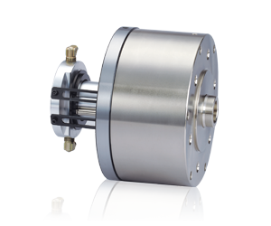
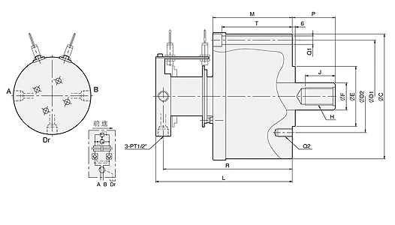
UNIT : mm
SPEC  Model | Piston  Dia.  (mm) | Piston Area  (cm²)  Push Side / Pull Side | Max. Draw Bar Force  KN(kgf)  Push Side / Pull Side | Piston  Stroke  (mm) | Max.  Operating  Pressure  MPa  (kgf / cm²) | Max.  Speed  (r.p.m.) | Moment  Of Inertia  I  (kg‧m² ) | Weight  (kg) | Total  Leakage  L/min
MR15035 | 150 | 171.1 / 156.7 | 72(7342) / 66(6730) | 35 | 4.5(45.9) | 5500 | 0.043 | 12.8 | 0.8
MR20060 | 200 | 310 / 286 | 146(14887) / 134(13664) | 60 | 4.9(50) | 5000 | 0.55 | 49 | 2
MR25060 | 250 | 481.5 / 453.6 | 227(23147) / 214(21822) | 60 | 4.9(50) | 2000 | 0.81 | 72 | 2

DIM  Model | C | C1 | D1 | D2 | E  (h7) | F | G | H | J | L | M | P  max. | P  min. | Q1 | Q2 | R | T | Z
MR15035 | 202 | 204 | 180 | 130 | 110 | 110 | 45 | M30x3.5 | 45 | 175 | 95 | 61 | 26 | 6-Ø13 | 12-M12 | 163 | 82 | 5
MR20060 | 250 | 225 | 225 | 145 | 120 | 55 | 37 | M36xP4.0 | 60 | 270 | 156 | 85 | 25 | 6-Ø17 | 6-M16 | 255 | 140 | 6
MR25060 | 300 | 305 | 275 | 220 | 160 | 65 | 44 | M42xP3.0 | 60 | 280 | 168 | 85 | 25 | 6-Ø17 | 6-M20 | 265 | 150 | 6

