KA

3-jaw strong scroll chuck A1 direct mounting, 2-piece jaws
(ASA spindle nose A1-5, A1-6) American standard camlock type with 2-piece reversible hard top jaws.
- Gripping accuracy of 0.03mm (0.0012 inch) T.I.R..
- Standard accessories chuck wrench, hex. key. and a set of mounting bolts. (UNC-bolts)
- The body is made of MEEHANITE. It is suitably used for high speed revolution and 3 times more durable than regular material.
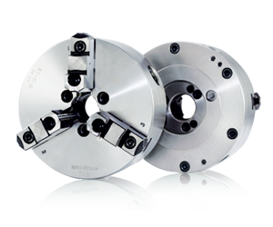
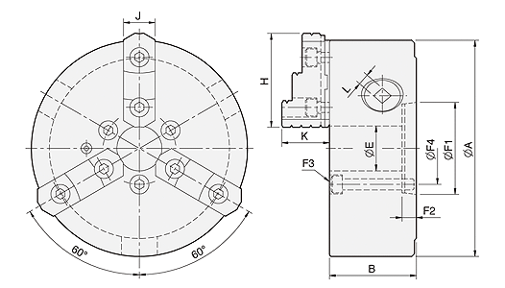
UNIT : mm
SPEC  Model | Spindle  Size | A | B | E | H | J | K | L | Mounting  Dimensions | Allowable  Handle  Torque  (kgf‧m) | Gripping  Force  (kgf) | Max.  Speed  (r.p.m.) | Weight  (kg) | Moment  Of Inertia I  (kg‧m² ) | Gripping Range
 |  |  |  |  |  |  |  |  | F1 / F2 / F3 / F4 |  |  |  |  |  | O.D. Range / I.D. Range
KD5-8" | A1-5 | 200 | 77.2 | 40 | 81.2 | 28 | 42.2 | 11 | 82.563 / 14.288 / 3-M10 / 61.9 | 11.0 | 2500 | 2000 | 18 | 0.07 | Ø8-Ø180 / Ø62-Ø170
KD6-8" | A1-6 | 200 | 77.2 | 53 | 81.2 | 28 | 42.2 | 11 | 106.375 / 15.875 / 3-M12 / 82.6 | 11.0 | 2500 | 2000 | 18 | 0.07 | Ø8-Ø180 / Ø62-Ø170
KD6-10" | A1-6 | 250 | 86 | 53 | 90.9 | 32 | 50.8 | 12 | 106.375 / 15.875 / 3-M12 / 82.6 | 19.0 | 4000 | 1800 | 29.5 | 0.2 | Ø11-Ø220 / Ø70-Ø210
KD6-12" | A1-6 | 306 | 107.5 | 53 | 114.5 | 40 | 57.8 | 14 | 106.375 / 15.875 / 3-M12 / 82.6 | 21.0 | 4200 | 1800 | 47 | 0.5 | Ø15-Ø300 / Ø90-Ø290
KD8-12" | A1-8 | 306 | 107.5 | 77 | 114.5 | 40 | 57.8 | 14 | 139.719 / 17.462 / 6-M16 / 111.1 | 21.0 | 4200 | 1800 | 47 | 0.5 | Ø15-Ø300 / Ø90-Ø290

