SK

3-jaw strong scroll chuck plain back, 2-piece jaws (front and back mounted)
- SK types chucks have wider unilization range; hard jaws suitable for heavy cutting; soft jaws suitable for light and precision cutting.
- Hard jaws could be used as internal jaws and external jaws.
- Gripping accuracy of 0.03mm (0.0012 inch) T.I.R.
- The body is made of MEEHANITE. It is suitably used for high speed revolution and 3 times more durable than regular material.
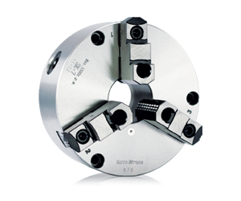
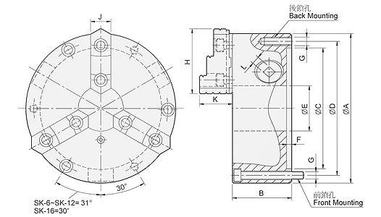
UNIT : mm
SPEC  Model | A | B | C | D | E | F | G | H | J | K | L | Allowable  Handle  Torque  (kgf‧m) | Gripping  Force  (kgf) | Max.  Speed  (r.p.m.) | Weight  (kg) | Moment  Of Inertia I  (kg‧m² ) | Gripping Range
 |  |  |  |  |  |  | Back / Front |  |  |  |  |  |  |  |  |  | O.D. Range / I.D. Range
SK-4 | 112 | 58 | 80 | 95 | 32 | 4.8 | — / 3-M8x65 | 47 | 19 | 31.6 | 8 | 4.5 | 1200 | 2500 | 3.8 | - | Ø3-Ø95 / Ø29-Ø84
SK-6 | 167 | 67 | 130 | 147 | 45 | 5.5 | 3-M10 / 3-M10x70 | 72 | 26 | 40.2 | 10 | 9.0 | 2200 | 2000 | 9 | 0.03 | Ø4-Ø160 / Ø55-Ø150
SK-7 | 192 | 76.5 | 155 | 172 | 58 | 5.5 | 3-M10 / 3-M10x80 | 81.2 | 28 | 42 | 11 | 11.0 | 2500 | 2000 | 13.8 | 0.06 | Ø8-Ø180 / Ø62-Ø170
SK-8 | 200 | 76.5 | 160 | 176 | 58 | 5.5 | 3-M10 / 3-M10x80 | 82 | 28 | 42 | 11 | 11.0 | 2500 | 2000 | 15.5 | 0.07 | Ø8-Ø190 / Ø68-Ø180
SK-9 | 232 | 84 | 190 | 210 | 70 | 6 | 3-M12 / 3-M12x90 | 90.9 | 32 | 51.2 | 12 | 15.0 | 3000 | 2000 | 22 | 0.16 | Ø11-Ø220 / Ø70-Ø210
SK-10 | 273 | 87 | 230 | 250 | 89 | 8 | 3-M12 / 3-M12x90 | 100.5 | 35 | 56.7 | 12 | 19.5 | 4000 | 1800 | 29.7 | 0.26 | Ø12-Ø260 / Ø80-Ø250
SK-12 | 310 | 96 | 260 | 285 | 105 | 7 | 3-M12 / 3-M12x110 | 114.5 | 40 | 56.8 | 14 | 21.0 | 4200 | 1800 | 43.5 | 0.58 | Ø15-Ø300 / Ø90-Ø290
SK-16 | 405 | 122 | 345 | 375 | 160 | 8.7 | — / 6-M14x130 | 148.6 | 50 | 76.1 | 15 | 25.0 | 4500 | 1500 | 98 | 1.72 | Ø30-Ø380 / Ø110-Ø360

