SIC

4-jaw scroll chuck plain back, solid jaws (front and back mounted)
- Gripping of square or octagonal workpieces could fit into central line automatically.
- SIC have high stability in gripping thin tube work piece.
- The specification is the same as SC type.
- The body is made of MEEHANITE. It is suitably used for high speed revolution and 3 times more durable than regular material.
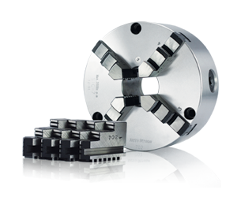
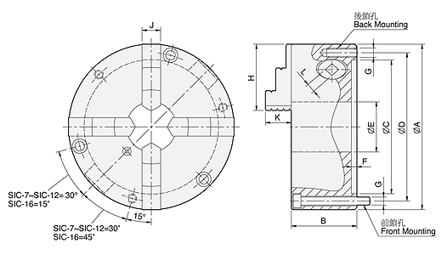
UNIT : mm
SPEC  Model | A | B | C | D | E | F | G | H | J | K | L | Allowable  Handle  Torque  (kgf‧m) | Gripping  Force  (kgf) | Max.  Speed  (r.p.m.) | Weight  (kg) | Moment  Of Inertia I  (kg‧m² ) | Gripping Range
 |  |  |  |  |  |  | Back / Front |  |  |  |  |  |  |  |  |  | O.D. Range / I.D. Range
SIC-7 | 192 | 76.5 | 155 | 172 | 58 | 5.5 | 3-M10 / 3-M10x8 | 77 | 21.5 | 29.4 | 11 | 11.0 | 2500 | 2000 | 14.8 | 0.06 | Ø4-Ø180 / Ø56-Ø170
SIC-9 | 232 | 84 | 190 | 210 | 70 | 6 | 3-M12 / 3-M12x90 | 87 | 24 | 35.6 | 12 | 15.0 | 3000 | 2000 | 23.2 | 0.16 | Ø5-Ø220 / Ø62-Ø210
SIC-12 | 310 | 96 | 260 | 285 | 105 | 7 | 3-M12 / 3-M12x110 | 110 | 30 | 45.6 | 14 | 21.0 | 4200 | 1800 | 47 | 0.58 | Ø10-Ø300 / Ø86-Ø290
SIC-16 | 405 | 122 | 345 | 375 | 160 | 8.7 | - / 6-M14x130 | 146 | 42 | 56.3 | 15 | 25.0 | 4500 | 1500 | 107 | 1.75 | Ø30-Ø380 / Ø110-Ø360

